**CAPSTONE PROJECT**

**EXPLORING MOVIE REVIEW**

Presented By:

1. ASWIN V.S-Ponjesly College of Engineering-Civil Engineering

## OUTLINE

* **Problem Statement**
* **Proposed System/Solution**
* **System Development Approach**
* **Algorithm & Deployment**
* **Result**
* **Conclusion**
* **Future Scope**
* **References**

# PROBLEM STATEMENT

* Movie dataset for binary sentiment classification containing substantially more data than previous benchmark datasets. We provide a set of 25,000 highly polar movie reviews for training and 25,000 for testing. So, predict the number of positive and negative reviews using either classification or deep learning algorithms.



# PROPOSED SOLUTION

* + **Exploring movie reviews can be approached in several ways. One effective solution is to create a web application or mobile app that aggregates reviews from multiple sources such as IMDb, Rotten Tomatoes, Metacritic, and user-generated reviews from platforms like Letterboxd.**
  + **The app could allow users to search for movies, view aggregated ratings, read critic and user reviews, and even provide personalized recommendations based on their viewing history and preferences. Additionally, implementing features like filtering by genre, release year, and director can enhance the user experience.**
* **BENEFITS :**
* Informed Decision Making: Movie reviews help viewers make informed decisions about which

movies to watch, saving time and money by avoiding disappointing films.

* Diverse Perspectives: Reading reviews from critics and fellow moviegoers provides diverse perspectives on a film, Offering insights into its quality, themes, and entertainment value.
* Discovering Hidden Gems : Exploring reviews can uncover lesser-known movies that may not

have received widespread attention but are highly acclaimed by critics or loved by audiences.

# SYSTEM APPROACH

A systematic approach to exploring movie reviews involves several steps:

* Identify Sources: Start by identifying reputable sources of movie reviews, such as professional critics, film websites, or audience-based platforms like Rotten Tomatoes, IMDb, or Metacritic.
* Set Criteria: Determine what criteria are important to you when evaluating a movie, such as genre, director, cast, or thematic elements. This will help you narrow down your search and focus on relevant reviews.
* Read Multiple Reviews: Don't rely solely on one review; instead, read multiple reviews from different sources to get a comprehensive understanding of a movie's strengths and weaknesses. Look for patterns or consensus among reviewers.
* Consider Different Perspectives: Pay attention to the perspective and biases of the reviewers. Some may focus more on technical aspects, while others may prioritize emotional impact or cultural relevance. Consider how these perspectives align with your own preferences.
* Analyze Critically: Approach reviews with a critical mindset, considering the credibility of the source, the depth of analysis, and the coherence of arguments. Look for reviews that provide thoughtful insights and analysis rather than just subjective opinions.

# ALGORITHM & DEPLOYMENT

Developing an algorithm for exploring movie reviews involves several steps.

Here's a basic outline:

Data Collection:

* + Gather movie review data from various sources such as IMDb, Rotten Tomatoes, Metacritic, or specialized film

critics' websites.

Sentiment Analysis:

* + Utilize sentiment analysis techniques to classify the sentiment of each review (positive, negative, or neutral).

Topic Modeling:

* + Apply topic modeling algorithms such as Latent Dirichlet Allocation (LDA) or Non-Negative Matrix Factorization (NMF) to identify key topics or themes discussed in the reviews.

Recommendation System:

* + Develop a recommendation system that suggests movies to users based on their preferences and past

interactions.

User Interface Development:

* + Design and develop a user-friendly interface where users can interact with the system.

# RESULT

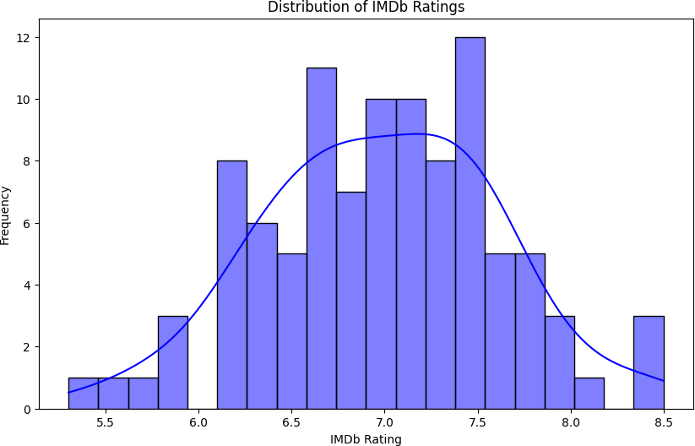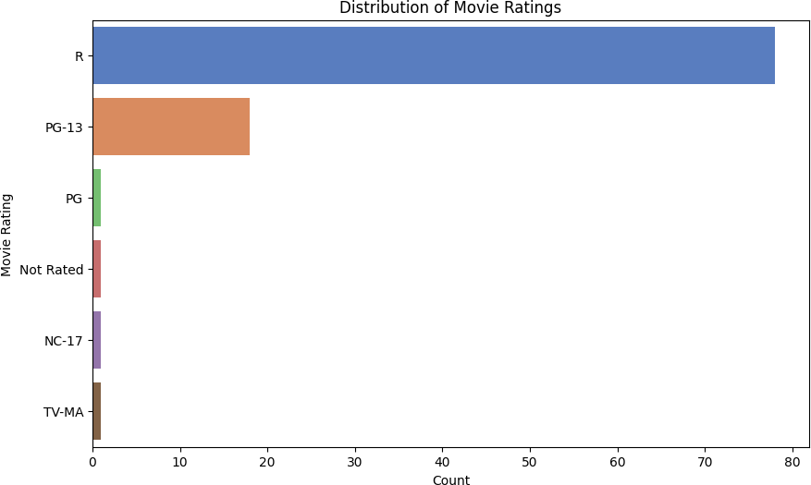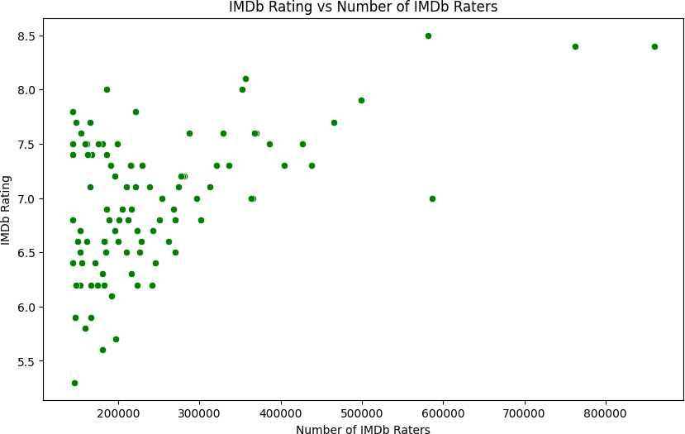

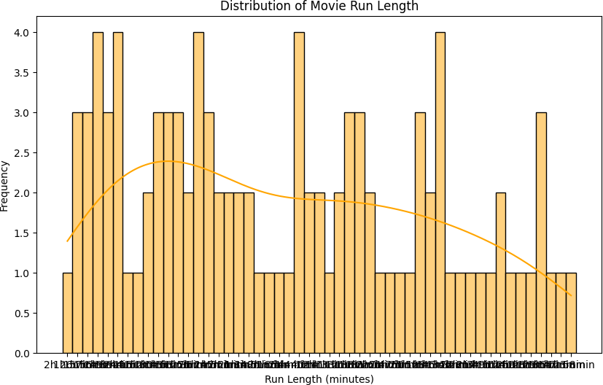

**CONCLUSION**

* + In conclusion, exploring movie reviews offers valuable insights into audience perceptions, critical analysis, and cultural impact. By delving into various reviews, one gains a nuanced understanding of a film's strengths, weaknesses, and overall reception. Whether for personal enjoyment, academic study, or professional critique, analyzing movie reviews provides a multifaceted perspective that enhances appreciation and understanding of cinema as an art form

**FUTURE SCOPE**

The future scope for movie reviews encompasses several exciting avenues:

### AI-Driven Analysis:

Continued advancements in artificial intelligence and natural language processing will enable more sophisticated analysis of movie reviews. AI algorithms could extract deeper insights from reviews, such as identifying subtle themes, character analyses, and predicting box office success.

### Personalized Recommendations:

With the abundance of data available, personalized movie recommendations will become more precise. AI algorithms will tailor suggestions based on individual preferences, viewing history, and even mood, leading to a more satisfying movie-watching experience.

### Global Reach:

With the globalization of cinema, there will be an increased demand for reviews that cater to diverse cultural contexts. Platforms may offer translations, localized content, and regional perspectives to accommodate global audiences.

# REFERENCES

* https://www.google.com/gasearch?q=kaggle%20dataset&tbm=&source=sh/x/gs/m2/5
* https://www.google.com/gasearch?q=chatgpt&tbm=&source=sh/x/gs/m2/5
* https://www.google.com/gasearch?q=vs%20code&tbm=&source=sh/x/gs/m2/5
* https://www.google.com/gasearch?q=google&tbm=&source=sh/x/gs/m2/5

**THANK YOU**